THE NATIONAL MEMORIAL DAY PARADE

AGREEMENT OF RELEASE
DUE BY MAY 12, 2015
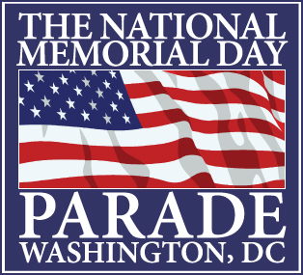

The National Memorial Day Parade return completed, signed forms to this address:
C/o American Veterans Center Under the Sun Productions, Inc
1100 North Glebe Road Suite 910 882 South Matlack Street, Suite 202
Arlington, VA 22201 West Chester, PA 19382

The undersigned will appear in the National Memorial Day Parade being produced by the American Veterans Center on Monday, May 25, 2015. The parade is being given as a public service.

I assume any and all risks associated with participating in the events and particular activities that I agree to undertake, including but not limited to negligent or reckless acts by other participants and volunteers, all such risks being known and appreciated by me. I also agree to abide by the rules of the events as set forth by designated officials and supervisors.

Knowing these facts, and in consideration for being permitted to participate in the parade, I hereby, for myself, and on behalf of the members of my organization and my heirs, executors, administrators, successors, assigns, or anyone else who might claim on my behalf, covenant not to sue, and waive release and discharge the American Veterans Center, The District of Columbia, The National Park Service, JM Best Entertainment Inc., Under the Sun Productions Inc., any and all parade sponsors, and each of them, their officials, agents, designated event supervisory personnel or anyone acting for or on their behalf, from any and all losses, costs (including without limitation, litigation costs, and attorney fees), claims, damages, suits, actions, demands, liability, and expenses in connection with loss of life, personal injury and/or property damage of any kind whatsoever, in law or in equity, arising out of or in the course of my participation in the event.

The undersigned does hereby release his/her voice, biography, audio/visual clips and likeness(es) solely in connection with the promotion, advertising for this year and subsequent festivals, and archival use of the Parade (including print, radio, television, and Internet advertising and promotions, including promotional materials). The undersigned hereby grants the American Veterans Center the right to broadcast, and /or to authorize others to broadcast, via radio, television, cable television, Internet, or otherwise. Clips provided that any such broadcast will be solely for purposes of promoting the Parade. Undersigned acknowledges and agrees that prior to, during or after the Parade, producers may, but will not be obligated to, disseminate information and various materials concerning the Event via the Internet, various online services or through other means or media.

The undersigned hereby accepts sole responsibility for the conduct and operation in the parade. The undersigned agrees that he/she/it will not involve or conduct itself in any manner that would negatively impact the good reputation of the parade. The undersigned agrees to be legally bound hereby.

Name ___________________________________________________________________________________

Name of Organization _________________________________________________________________________

Address ____________________________________________________________________________________

City ____________________________________________ State _______________ Zip ____________________

Date ________________________________________________________________________________________

Signature _____________________________________________________________________________________
(Parental signature required, if under 18 years of age)

